# 实验一

## 运行结果

## 代码截图

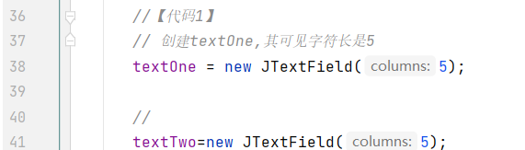

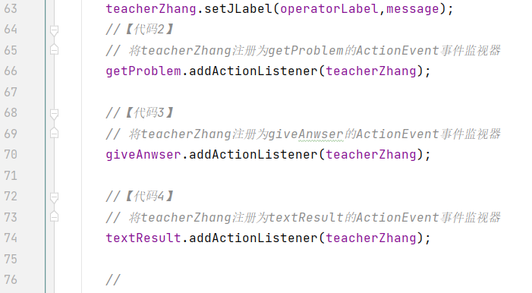

## 代码

package chapter9_1;

public class MainClass {

public static void main(String args[]) {

ComputerFrame frame;

frame=new ComputerFrame();

frame.setTitle("算术测试");

frame.setBounds(100,100,650,180);

}

}

//

package chapter9_1;

import java.util.Random;

import java.awt.event.*;

import javax.swing.*;

public class Teacher implements ActionListener {

int numberOne,numberTwo;

String operator="";

boolean isRight;

Random random; //用于给出随机数

int maxInteger; //题目中最大的整数

JTextField textOne,textTwo,textResult;

JLabel operatorLabel,message;

Teacher() {

random = new Random();

}

public void setMaxInteger(int n) {

maxInteger=n;

}

public void actionPerformed(ActionEvent e) {

String str = e.getActionCommand();

if(str.equals("getProblem")) {

numberOne = random.nextInt(maxInteger)+1;//1至maxInteger之间的随机数;

numberTwo=random.nextInt(maxInteger)+1;

double d=Math.random(); // 获取(0,1)之间的随机数

if(d>=0.5)

operator="+";

else

operator="-";

textOne.setText(""+numberOne);

textTwo.setText(""+numberTwo);

operatorLabel.setText(operator);

message.setText("请回答");

textResult.setText(null);

}

else if(str.equals("answer")) {

String answer=textResult.getText();

try{ int result=Integer.parseInt(answer);

if(operator.equals("+")){

if(result==numberOne+numberTwo)

message.setText("你回答正确");

else

message.setText("你回答错误");

}

else if(operator.equals("-")){

if(result==numberOne-numberTwo)

message.setText("你回答正确");

else

message.setText("你回答错误");

}

}

catch(NumberFormatException ex) {

message.setText("请输入数字字符");

}

}

}

public void setJTextField(JTextField ... t) {

textOne=t[0];

textTwo=t[1];

textResult=t[2];

}

public void setJLabel(JLabel ...label) {

operatorLabel=label[0];

message=label[1];

}

}

//

package chapter9_1;

import java.awt.*;

import java.awt.event.*;

import javax.swing.*;

public class ComputerFrame extends JFrame {

JMenuBar menubar;

JMenu choiceGrade; //选择级别的菜单

JMenuItem grade1,grade2;

JTextField textOne,textTwo,textResult;

JButton getProblem,giveAnwser;

JLabel operatorLabel,message;

Teacher teacherZhang;

ComputerFrame() {

teacherZhang=new Teacher();

teacherZhang.setMaxInteger(20);

setLayout(new FlowLayout());

menubar = new JMenuBar();

choiceGrade = new JMenu("选择级别");

grade1 = new JMenuItem("幼儿级别");

grade2 = new JMenuItem("儿童级别");

grade1.addActionListener(new ActionListener() {

public void actionPerformed(ActionEvent e) {

teacherZhang.setMaxInteger(10);

}

});

grade2.addActionListener(new ActionListener() {

public void actionPerformed(ActionEvent e) {

teacherZhang.setMaxInteger(50);

}

});

choiceGrade.add(grade1);

choiceGrade.add(grade2);

menubar.add(choiceGrade);

setJMenuBar(menubar);

//【代码1】

// 创建textOne,其可见字符长是5

textOne = new JTextField(5);

//

textTwo=new JTextField(5);

textResult=new JTextField(5);

operatorLabel=new JLabel("+");

operatorLabel.setFont(new Font("Arial",Font.BOLD,20));

message=new JLabel("你还没有回答呢");

getProblem=new JButton("获取题目");

giveAnwser=new JButton("确认答案");

add(getProblem);

add(textOne);

add(operatorLabel);

add(textTwo);

add(new JLabel("="));

add(textResult);

add(giveAnwser);

add(message);

textResult.requestFocus();

textOne.setEditable(false);

textTwo.setEditable(false);

getProblem.setActionCommand("getProblem");

textResult.setActionCommand("answer");

giveAnwser.setActionCommand("answer");

teacherZhang.setJTextField(textOne,textTwo,textResult);

teacherZhang.setJLabel(operatorLabel,message);

//【代码2】

// 将teacherZhang注册为getProblem的ActionEvent事件监视器

getProblem.addActionListener(teacherZhang);

//【代码3】

// 将teacherZhang注册为giveAnwser的ActionEvent事件监视器

giveAnwser.addActionListener(teacherZhang);

//【代码4】

// 将teacherZhang注册为textResult的ActionEvent事件监视器

textResult.addActionListener(teacherZhang);

//

setVisible(true);

validate();

setDefaultCloseOperation(DISPOSE_ON_CLOSE);

}

}